MSc Project Proposal Template

Analysing Machine Learning Methods for Predicting Flood Risk Using Historical Rainfall and River Observation Data

Student Name : Nathish Moorthy

Student Id : A00050245

Department : Msc Data Science

Table of Contents
1. Introduction 3
1.1 Background to Flood Prediction 3
1.2 Machine Learning and Flood Risk Analysis 3
1.3 Research Context and Dataset Overview 3
2. Problem Statement 3
2.1 Flood Risk as a Critical Environmental Challenge 3
2.2 Current Challenges in Flood Prediction 4
2.2.1 Limited Predictive Capability of Traditional Hydrological Models 4
2.2.2 Complexity of Environmental and Hydrological Interactions 4
2.2.3 Lack of Comparative Evaluation of Machine Learning Techniques 4
2.3 Research Gap 4
2.4 Research Questions 4
3. Aims and Objectives 4
3.1 Research Aim 4
3.2 Research Objectives 4
3.3 Scope of the Study 5
3.4 Expected Academic and Practical Contribution 5
4. Legal, Social, Ethical and Professional Considerations 5
4.1 Legal Considerations 5
4.2 Ethical Considerations 5
4.3 Social Considerations 5
4.4 Professional Considerations 5
5. Background (1500 words) 5
5.1 Introduction to Flood Risk Prediction and Research Context 5
5.2 Evolution of Flood Prediction Methods 6
5.3 Theoretical and Technical Foundations of Machine Learning 6
5.4 Critical Review of Flood Risk Factors 7
5.5 Critical Comparison of Previous Empirical Studies 8
5.6 Research Gap, Project Positioning and Wider Relevance 8
6. References 9

1. Introduction

1.1 Background to Flood Prediction
Flooding is one of the most common and most destructive natural disasters of the world resulting in significant economic losses, environmental degradation and threats to human life [1]. Flooding is responsible for around 43% of all natural disasters recorded worldwide and impacted over 1.6 billion people from 2000 to 2019 [2].
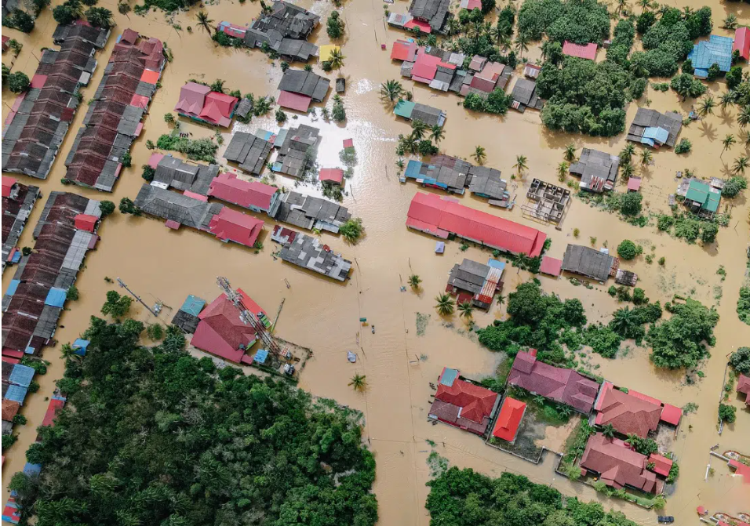
Figure 1: Flooding
(Source: Lai, 2023)

India is particularly vulnerable, with almost 40 million hectares of land facing the flood risks. Climate change has been blamed for the increased and intensified frequency of flooding events, as has the rapid urbanisation and changing rainfall patterns [3]. The effects of these challenges have stressed the urgent need to develop accurate flood prediction systems to help disaster preparedness, timely warnings and effective flood risk management strategies.

1.2 Machine Learning and Flood Risk Analysis
The development of Artificial Intelligence (AI) and Machine Learning (ML) has revolutionised flood risk analysis, the ability to process big and complex data sets [4]. Machine learning models can provide more accurate predictions than traditional forecasting methods by discovering patterns between different variables and making predictions based on them. The capabilities of ML are beneficial in supporting disaster management decisions and flood forecasting.

1.3 Research Context and Dataset Overview
The Flood Risk Prediction Dataset in India will be used for this study, consisting of 14 variables comprising meteorological, hydrological, geographical and socio-economic parameters, along with 1,000 observations. Rainfall, river discharge, river level, humidity, elevation and past flood history are all important parameters. The dataset offers a suitable basis for testing machine learning techniques to predict flood risks.

2. Problem Statement

2.1 Flood Risk as a Critical Environmental Challenge
Flooding is one of the top environmental issues in the world, impacting millions of people annually and resulting in considerable economic, social and environmental implications [5]. Climatic variation, monsoon variability and rising urbanisation are responsible for making floods one of the most common natural disasters in India. Floods often kill people, displace communities, destroy infrastructure, damage agriculture and disrupt economic activities. With the changing intensities of rainfall and weather patterns due to climate change, the number of flood events is expected to increase as will the severity [6]. Therefore it is essential that reliable flood forecasting systems be developed to enhance disaster preparedness and minimise potential losses.

2.2 Current Challenges in Flood Prediction

2.2.1 Limited Predictive Capability of Traditional Hydrological Models
The traditional hydrological models have been applied to flood forewarning for a long time, but its applications are still limited by the assumption setting and complicated calibration process [7]. The difficulty in accurately representing changing environmental conditions and non-linear relationships between flood-related variables can reduce the accuracy of the prediction made by these models.

2.2.2 Complexity of Environmental and Hydrological Interactions
There are many factors that affect flood occurrence such as rainfall, river discharge, water level, elevation, soil type and land cover and historical flood patterns. Interpretation and modelling of these complex interactions can sometimes be difficult with traditional analytical methods, especially if there are many data points [8].

2.2.3 Lack of Comparative Evaluation of Machine Learning Techniques
While machine learning has been extensively used to study the flood prediction problem, few studies have been conducted to compare multiple algorithms in a single study to assess their performance [9]. Therefore it is not known which machine learning model is the more effective on the same types of datasets and same environmental conditions. The absence of comparative analysis leaves uncertainty about which algorithm to use for flood forecasting and further study is needed to systematically test and compare the various machine learning techniques.

2.3 Research Gap
Machine Learning (ML) methods have been shown to be effective in enhancing the accuracy of flood forecasting in previous research. However there is a lack of systematic research to compare the performance of various machine learning algorithms using complete flood risk data sets. Additionally there have been inconsistent results across studies due to differences in data characteristics, feature selection methods and evaluation metrics. This variation raises doubts about which of these models would be the best to use for flood risk assessment. Therefore there is a need for additional comparative studies to find a reliable and effective machine learning method to make accurate predictions of floods and to help in disaster management.

2.4 Research Questions
RQ1: Which machine learning algorithm provides the highest performance for flood risk prediction?
RQ2: Which variables contribute most significantly to flood occurrence?
RQ3: How can machine learning support flood risk management and early-warning systems?

3. Aims and Objectives

3.1 Research Aim
This research is designed to compare machine learning techniques for predicting flood risks based on historical rainfall and river data to find which technique is the most effective for accurate flood prediction and disaster management.

3.2 Research Objectives
To achieve the objective of the research, the following objectives are.
Objective 1: To understand machine learning-based flood risk prediction within disaster management and environmental forecasting contexts.
Objective 2: To examine the influence of environmental and hydrological variables on flood occurrence patterns.
Objective 3: To identify challenges affecting accurate flood prediction and limitations of traditional forecasting approaches.
Objective 4: To compare machine learning methods with traditional flood prediction techniques for forecasting accuracy.
Objective 5: To provide recommendations based on research findings for improving flood risk prediction systems.

3.3 Scope of the Study
This study focuses on secondary data analysis on the India's Flood Risk Prediction Dataset. The research utilises supervised machine learning classification techniques and comparative model evaluation based on historical rainfalls, river discharge and water level as well as other related variables. This research doesn’t involve the real-time monitoring systems, or Internet of Things (IoT) based flood forecasting systems.

3.4 Expected Academic and Practical Contribution
From an academic perspective, this study will add to the previous body of work that has been done on machine learning applications in flood forecasting by comparing various predictive algorithms and their ability to predict flood risk [10]. The research will also contribute to the understanding of how environmental and hydrological factors are related to the occurrence of floods. The results can also guide disaster management and policy makers in enhancing the accuracy of flood forecasting, early-warning systems, and effective flood risk mitigation and disaster preparedness strategies, from a practical perspective.

4. Legal, Social, Ethical and Professional Considerations

4.1 Legal Considerations
The data used in this study is the Flood Risk Prediction Dataset in India. Therefore it is crucial to remain to the license and requirements of the dataset to use the data legally [11]. The data source will be acknowledged and cited throughout the research. Also, in using secondary literature, datasets and other academic sources in the study, IP and copyright laws will be followed to ensure academic integrity and to prevent plagiarism.

4.2 Ethical Considerations
While this research is conducted with secondary data and not with human subjects, ethical issues are still relevant. The integrity of data will be ensured by the accurate collection, processing and analysis procedures. Therefore the modelling process will be transparent and reproducible ensure the credibility of the research [12]. Also, the implications of algorithmic bias and algorithmic fairness will be considered for understanding results.

4.3 Social Considerations
The social value of accurate flood prediction is high because it can enhance the ability of public safety, disaster loss reduction and effective emergency response planning. Better forecasting can help build community resilience by informing authorities to take early action for mitigation [13]. Better flood risk forecasting could also play a role in safeguarding critical infrastructure and populations against the negative impacts of flooding.

4.4 Professional Considerations
The research will conduct in accordance with the consistent with accepted scientific research and data analytics industry norms. Compliance with research ethics will guarantee that there will be no breaches of data integrity and ethics. The principles of reproducibility’s will be followed to ensure transparency and verification of results. Additionally best practices will be observed to reduce bias and promote equity in model building using Artificial Intelligence. The results will be interpreted by adopting evidence-based decision-making and the conclusions will be reliable, transparent and professional in the entire scope of the study [14].

5. Background (1500 words)

5.1 Introduction to Flood Risk Prediction and Research Context
Flooding is one of the most destabilising natural hazards which has widespread environmental, economic and social impacts that are likely to increase with climate change and increasing urbanisation. According to study the combined impacts of climatic variability and population increase are augmenting world flood exposure, particularly in highly populated areas where infrastructure and settlements are very susceptible [15]. Flood prediction has therefore become a strategic aspect of disaster risk management not necessarily a hydrological undertaking. The another study noted that modern forecasting models are more prone to bring together prediction and preparedness as well as early-warning systems to reduce losses and enhance resilience [16]. Such a shift has catalysed the use of analytical methods that use data and identify patterns in big environmental data. The current study fits into this changing research background to investigate the possibility of utilising machine learning in improving the prediction of flood risks by using historical data of rainfalls and river observations.
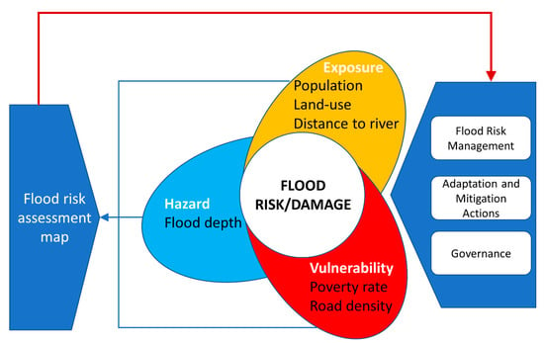
Figure 1: Flood risk assessment and management framework
(Source: [17])

5.2 Evolution of Flood Prediction Methods
The changing environment and availability of data have shifted flood forecasting to an intelligent and data-driven forecasting as opposed to the traditional hydrological modelling. Traditional forecasting methods were mainly based on the rainfall-runoff relation and hydraulic simulation that characterised the flood behaviour based on predetermined physical equations. The study claimed that such strategies provided the theoretical foundation of flood forecasting and are crucial to comprehending watershed processes [18]. Their usefulness can often be reliant on detailed catchment data, wide calibration and assumptions on physical processes that can vary with a shifting climate. These limitations reduce their flexibility in areas with heterogeneous environmental conditions and incomplete observations.
The initiation of remote sensing technology, big hydrological information and improvements in computing power have contributed to the rapid proliferation of machine learning-driven forecasting systems. The another study have shown that combining physical knowledge with statistical learning can allow the use of hybrid machine learning hydrological models to model complex processes that produce floods [19]. Similarly, other study determined that machine learning algorithms often outperform traditional ones due to their ability to learn nonlinear relationships directly based on past data and do not have to have explicit process equations [20]. However, this study warned against replacing hydrological theory but instead complementing it with adaptive and evidence-based prediction [21]. Recent studies are thus more encouraging towards hybrid structures in which conventional science is coupled with machine learning abilities to enhance the dependability of predictions and decision-making.

5.3 Theoretical and Technical Foundations of Machine Learning
The flood forecasting application of Artificial Intelligence is based on machine learning algorithms that can see the hidden patterns in multidimensional environmental data. In contrast to deterministic models, supervised machine learning constructs predictive functions through learning based on labelled past observations and is hence suited to binary classification problems, like predicting flood occurrence. As mentioned by [21], hydrological systems are complex and nonlinear and not all physical equations can be sufficiently modelled which opens the prospects of data-driven modelling.
Various supervised learning methods have gained some ground in the flood prediction studies. According to [20] the most used algorithms are Decision Trees, Random Forests, Support Vector Machines, Artificial Neural Networks and Logistic Regression as they can run on the various meteorological and hydrological variables and still have high predictive power. It was also proposed by [21] that ensemble and deep learning models increase forecasting accuracy as higher-order patterns in historical observations can be extracted but more complexity leads to a decrease in model interpretability. Addressing this trade-off has become an important theoretical consideration in environmental machine learning.
Recent work has been in support of the idea that machine learning should be combined with hydrological knowledge instead of being opposed to each other [22] and [19] showed that hybrid methods can enhance the forecasting performance because they use data to adapt and have physical process knowledge. The result of this development is that machine learning is currently being viewed as a recognised analytical framework that complements traditional flood forecasting theories, enabling more adaptable and evidence-based environmental decision-making.
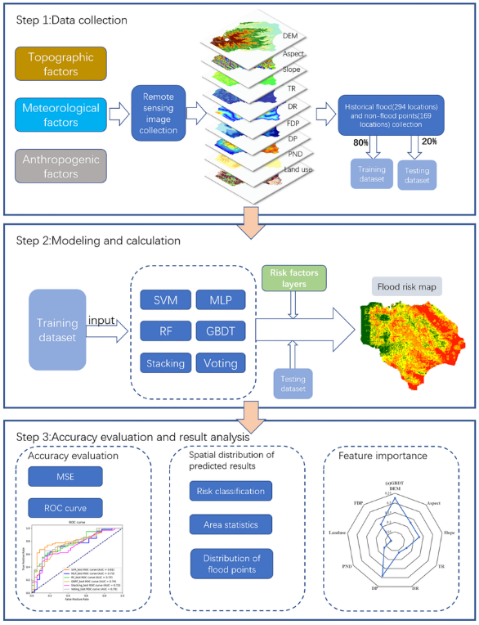
Figure 2: Flood risk assessment framework based on machine learning models
(Source: Zhang, et al., 2023)

5.4 Critical Review of Flood Risk Factors
The occurrence of floods depends on the interplay of meteorological, hydrological, geographical and socio-economic factors but not on rainfall. As a result, there has been an increasing trend in the recent flood predictions studies to make use of multidimensional datasets to model these multifaceted associations. [16] claimed that successful forecasting requires the inclusion of variables that capture both a physical hazard and a societal vulnerability as part of the wider shift towards flood estimation to a full risk assessment.
Rainfall is the most significant trigger of meteorological factors since excess precipitation directly raises the surface runoff and the river inflow. However, [23] showed that models that predict based on rainfall are more predictive when there are water level observations because the dynamic response of the river systems is reflected in hydrological indicators. Similarly, [24] discovered that discharge information combined with the presence of spatiotemporal environmental features can improve the capacity of machine learning models to detect changing flood conditions.
Geographical factors also contribute to the susceptibility to floods by impacting infiltration and flow movement. [25] pointed out that elevation, land cover and geomorphological factors are important in influencing flood behaviour, whereas [26] noted that topography and land use are also crucial in the evaluation of hazard. Social-economic variables such as population density, infrastructure and historical flood data give further information about exposure and resilience. Thus, the integration of environmental and social factors used in the present study indicates the up-to-date findings that the risk of floods is a complex phenomenon that cannot be accurately modelled using discrete hydrological measurements.

5.5 Critical Comparison of Previous Empirical Studies
The recent empirical studies have shown that machine learning can enhance the accuracy of flood forecasting, but the literature is still not complete due to the use of various datasets, predictor variables and evaluation approaches by the studies. As [21] have noted, the swift expansion of artificial intelligence tools in flood management has not been accompanied by the creation of standardised benchmarking systems and it is challenging to compare algorithms directly. Thus, the question of which modelling method is the most reliable to predict operational floods is an open issue.
Comparative studies typically prefer ensemble to single-model approaches to learning. [27] found that Random Forest and XGBoost had better predictions of flood susceptibility due to their ability to reduce overfitting and have good generalisation abilities. Again, [28] concluded that Random Forest and XGBoost consistently produced better results when used on national flood risk data in comparison to Support Vector Machines. However, these two works agreed that the quality of the algorithm largely relied on the choice of features and sampling methods, meaning that the quality of data is equally significant as the model design.
Several articles have also underlined the importance of combining machine learning and hydrological knowledge. [19] have shown that hybrid models that operate physical and data-driven models produced more accurate predictions compared to strictly statistical models. Conversely, [29] claimed that even though advanced algorithms often provide high predictive accuracy, they may not be useful in practice because the decision-makers are unable to understand the factors that affect predictions or assess the uncertainty of the models.
[30] emphasised that a lot of comparative research is based on localised observations which minimise the ability to generalise the results to other hydrological settings. Similarly, [31] found that reproducibility is hampered by inconsistent feature selection and validation processes and robust comparison of algorithms is delayed by inconsistent feature selection and validation. Altogether, the evidence indicates that further research is required which would compare several machine learning methods based on a single dataset with various environmental and socio-economic factors.

Author(s) | Model(s) | Key Finding | Main Limitation
[19] | Hybrid ML Hydrological Model | Improved forecasting by integrating physical and data-driven modelling | Catchment-specific application
[27] | Random Forest, XGBoost | Ensemble models reduced overfitting and improved prediction | Dependent on sampling strategy
[28] | RF, XGBoost, SVM | Ensemble algorithms outperformed SVM | Sensitive to feature engineering
[30] | Comparative ML models | Performance varied across hydrological settings | Limited transferability
[31] | Systematic review | Inconsistent validation reduces comparability | Lack of standardisation

5.6 Research Gap, Project Positioning and Wider Relevance
The literature review has indicated that machine learning is already a proven method of flood forecasting. However, some limitations have not been addressed. Current literature often tests single algorithms with localised datasets and inconsistent validation processes which makes it challenging to compare them. [31] noted that the lack of standardised methodologies diminishes the transferability and reproducibility of the existing flood prediction models. In the same line, [21] noted that a significant number of studies focus on predictive accuracy and pay limited attention to model interpretability and operational applicability.
This study fills these gaps by comparing various supervised machine learning algorithms based on a common dataset that combines meteorological, hydrological, geographical and socio-economic variables. In addition to the prediction performance, the study also investigates the contribution of individual flood indicators which further offer more insight into the mechanisms that contribute to the presence of floods. The project builds on the existing work by integrating comparative modelling with feature-based flood risk analysis.
The research results will have implications outside the academic world by informing more credible early-warning systems, evidence-based disaster planning and data-driven flood risk management policies to policymakers and emergency management agencies.

6.

References

[1] | World, "Floods," WHO, 2019.
[2] | I. Frege., "World Risk Report 2025 - Focus: Floods," Prevention Web, 2025.
[3] | J. Coalson,, E. Anderson, E. Santos, V. Garcia, J. Romine, J. Luzingu, B. Dominguez, D. Richard, A. Little, M. Hayden and K. Ernst, "The Complex Epidemiological Relationship between Flooding Events and Human Outbreaks of Mosquito-Borne Diseases: A Scoping Review," Environmental Health Perspectives, vol. 129, no. 9, 2021.
[4] | Z. Liu, N. Coleman, F. Patrascu, K. Yin, X. Li and A. Mostafavi, "Artificial intelligence for flood risk management: A comprehensive state-of-the-art review and future directions," International Journal of Disaster Risk Reduction, vol. 117, p. 105110, 2025.
[5] | Nationalgeographic, "The Many Effects of Flooding," National Geographic, 2019.
[6] | G. Nhamo,, L. Chapungu and G. Mutanda, "rends and impacts of climate-induced extreme weather events in South Africa (1920–2023)," Environmental Development, vol. 55, p. 101183, 2025.
[7] | P. Astagneau, F. Bourgin,, V. Andréassian and C. Perrin, "Lead-time-dependent calibration of a flood forecasting model," Journal of Hydrology, vol. 644, p. 132119, 2024.
[8] | P. Linardatos, V. Papastefanopoulos and S. Kotsiantis, "Explainable AI: A Review of Machine Learning Interpretability Methods," Entropy, vol. 23, no. 1, p. 18, 2020.
[9] | T. Asrade, S. Abebe, K. Tadesse, M. Kerebih and T. Meshesha, "Flood susceptibility assessment using three machine learning techniques and comparison of their performance," Scientific Reports, vol. 16, no. 1, 2026.
[10] | S. Dey, "A Comparative Study Of Machine Learning Algorithms For Flood Prediction In India," Research Gate, 2023.
[11] | P. Wang, X. Wu and Yichen, "Ai-driven approaches to flood risk management: overcoming data bias and enhancing decision-making," Climate Risk Management, vol. 50, p. 100752, 2025.
[12] | G. Miller and E. Spiegel, "Guidelines for Research Data Integrity (GRDI)," Scientific Data, vol. 12, no. 1, 2025.
[13] | CTCN, "Flood forecasting systems," CTCN, 2026.
[14] | D. Resnik and M. Hosseini, "The ethics of using artificial intelligence in scientific research: new guidance needed for a new tool," AI and Ethics, vol. 5, no. 2, p. 1499+1521, 2024.
[15] | J. Rogers, M. Maneta, S. Sain, L. Madaus and J. Hacker, "The role of climate and population change in global flood exposure and vulnerability," Nature Communications, vol. 16, no. 1, p. 1287, 2025.
[16] | K. Antwi-Agyakwa,, M. Afenyo and D. Angnuureng, "Know to predict, forecast to warn: A review of flood risk prediction tools," Water, vol. 15, no. 3, p. 427, 2023.
[17] | C. Luu, H. Tran, B. Pham, N. Al-Ansari, T. Tran, N. Duong, N. Dao, L. Nguyen, H. Nguyen, Thu Ta and H. Le, "Framework of spatial flood risk assessment for a case study in Quang Binh province, Vietnam," Sustainability, vol. 12, no. 7, p. 3058, 2020.
[18] | S. Reena, D. Harikrishnan and S. Salaji, "Evolution of Flood Forecasting: A Comprehensive Review of Traditional and Sophisticated Approaches," Nature Environment & Pollution Technology, vol. 25, no. 2, p. 1, 2026.
[19] | G. Kan, K. Liang, H. Yu, B. Sun, L. Ding, J. Li, X. He, and C. Shen, "Hybrid machine learning hydrological model for flood forecast purpose," Open Geosciences, vol. 12, no. 1, pp. 813-820, 2020.
[20] | A. Mosavi, P. Ozturk and K. Chau, "Flood prediction using machine learning models: Literature review," Water, vol. 10, no. 11, p. 1586, 2018.
[21] | V. Kumar, H. Azamathulla, K. Sharma, D. Mehta and K. Maharaj, "The state of the art in deep learning applications, challenges, and future prospects: A comprehensive review of flood forecasting and management," Sustainability, vol. 15, no. 13, p. 10543, 2023.
[22] | j. Noymanee and T. Theeramunkong, "Flood forecasting with machine learning technique on hydrological modeling," Procedia Computer Science, vol. 156, pp. 377-386, 2019.
[23] | A. Pathan, L. Sidek, H. Basri, M. Hassan, M. Khebir, , S. Omar, M. Khambali, A. Torres and A. Ahmed, "Comparative assessment of rainfall-based water level prediction using machine learning (ML) techniqueS," Ain Shams Engineering Journal, vol. 15, no. 7, p. 102854, 2024.
[24] | C. Chen, D. Luan, S. Zhao, Z. Liao, Y. Zhou, J. Jiang and Q. Pei, "Flood discharge prediction based on remote-sensed spatiotemporal features fusion and graph attention," Remote Sensing, vol. 13, no. 24, p. 5023, 2021.
[25] | E. Feloni, A. Anayiotos and E. Baltas, "A spatial analysis approach for urban flood occurrence and flood impact based on geomorphological, meteorological, and hydrological factors," Geographies, vol. 2, no. 3, pp. 516-527, 2022.
[26] | N. Dung, N. Long, R. Goyal, D. An and D. Minh, "The role of factors affecting flood hazard zoning using analytical hierarchy process: a review," Earth Systems and Environment, vol. 6, no. 3, pp. 697-713, 2022.
[27] | H. Ren, B. Pang, P. Bai, G. Zhao, S. Liu, Y. Liu and M. Li, "Flood susceptibility assessment with random sampling strategy in ensemble learning (RF and XGBoost)," Remote Sensing, vol. 16, no. 2, p. 320, 2024.
[28] | M. Mz, O. Nurhayati and J. Suseno, "Performance Comparison of Random Forest, XGBoost, and SVM for Flood Risk Prediction Using BNPB GIS Data," Journal of Information Systems and Informatics, vol. 8, no. 1, pp. 992-1010, 2026.
[29] | K. Khosravi, H. Shahabi, B. Pham, J. Adamowski, A. Shirzadi, B. Pradhan, J. Dou, H. Ly, G. Gróf, H. Ho and H. Hong, "A comparative assessment of flood susceptibility modeling using multi-criteria decision-making analysis and machine learning methods," Journal of hydrology, vol. 573, pp. 311-323, 2019.
[30] | J. Zhou, L. Chen, T. Hu, H. Lu, Y. Shi and L. Chen, "The comparative study of machine learning agent models in flood forecasting for tidal river reaches," Scientific Reports, vol. 15, no. 1, p. 19130, 2025.
[31] | T. Islam, E. Zeleke, M. Afroz and A. Melesse, "A systematic review of urban flood susceptibility mapping: Remote sensing, machine learning, and other modeling approaches," Remote Sensing, vol. 17, no. 3, p. 524, 2025.

